**DATE: 3/13/2013  
T0: MARK KOCHANSKI  
FROM: John Paul Wallway**

**TEAM MEMBERS: Sohaib Hussain, Paul Kwon, Anthony Hopkins, John Paul Wallway  
SUBJECT: TEAM IOBYTES STATUS REPORT: 3/6-3/13**

**Project Status:** Percent Complete 40% (Project breakdown by percentage: Analysis 40%, Design 65%, Construction 30%, Testing and Deployment 30%. Design is at roughly 65% completion, and will be 100% complete when all use cases and class diagrams are specified).

The PM Meeting this week covered what, when, and how the final company portfolio would be organized. All teams will have their individual portfolios in early by Monday, so a cohesive company portfolio can be put together. The design team completed the survey, but we did not get time to factor the results into development. This cycle, we began using source control for code, documents, and images--a definite step forward for the team. We also created a use case diagram and started working on actual PHP code, though we are very far from having an actual prototype. We also supplied feedback to the database team on their table schema and organization.

**WORK PLANNED FOR LAST WEEK**

* Begin using and backing up artifacts in source control (GIT)
* Create a Use Case Diagram
* Improve backlog configuration; make it easier to plan/trace tasks
* Implement a working prototype for website
* Finalize team portfolio
* Work with company divisions to generate final company portfolio
* Determine database calls needed for various pages

**WORK COMPLETED LAST WEEK – Encompassing Items from Backlog**

* Began using source control to track progress and backed-up versions
* Created a Use Case Diagra
* Finalized team portfolio
* Worked with teams to finalize company portfolio
* Began implementing PHP code and database calls
* Updated Backlog format
* Estimated remaining work to be done

**WORK PLANNED FOR NEXT WEEK AND BEYOND**

* [Beyond] implement working prototype for website (estimated 5 hours of work per week)
* [Beyond] implement features from backlog (estimated 10 hours of work per week)
* [Beyond] run prototype testing (estimated 5 hours of work per week)
* [Beyond] implement changes from testing (estimated 10 hours of work per week)
* [Beyond] finalize changes, run acceptance testing (estimated 15 hours of work per week)

**WEEK'S TASKS**

|  |  |  |  |  |  |  |
| --- | --- | --- | --- | --- | --- | --- |
| **Tasks** | **Planned** | **Forecasted** | **Actual** | **Status** | **Estimated**  **cost for this**  **week** | **Cost (in hours) this week** |
| Finalized team portfolio | (2/13/13) | (3/13/13) | 3/13/13 | Done | 12 | 20 hours |
| Created a Use Case Diagram | (2/28/13) | (3/13/13) | 3/13/2013 | Done | 2 | 2 hours |
| Began using source control to track progress and backed-up versions | (2/10/13) | (2/28/13) | 3/13/13 | Done | 4 | 8 hours |
| Began implementing PHP code and database calls | (3/11/13) | (3/13/13) | 3/13/13 | Done | 6 | 8 hours |
| Team task creation and division | (3/8/13) | (3/10/13) | 3/10/13 | Done | 2 | 2 hours |
| Correspondence | (3/11/13) | (3/11/13) | 3/10/13 | Done | 1 | 2 hours |
| Worked with teams to finalize company portfolio | (3/11/13) | (3/13/13) | 3/13/13 | Done | 1 | 2 hours |

Resources to be used in tasks: surveys, use case modeling software (possibly simple graphical image manipulation software), computers for communication, manpower (team BetaBytes).

**BetaByte Project Portfolio**

**PROJECT BACKLOG – Items are removed when they are brought into an iteration.**



**BetaByte Hours**

The following is an accounting of the hours spent by BetaByte team members throughout the 10 weeks of project development. Our goal was between 4 and 6 hours a week of work per person, approximately 160 - 240 hours of project work. The team achieved this, though there rests a huge portion of the project to complete, approximately 522 hours.



**Artifacts**

## Versions 1.0 of Artifacts

**Instructor view of the peer review page (version 1.0)**

The instructor can see each student’s work (via communication with the database, in construction and maintenance by the database team) for the peer rating retrievals, as well as the comments.

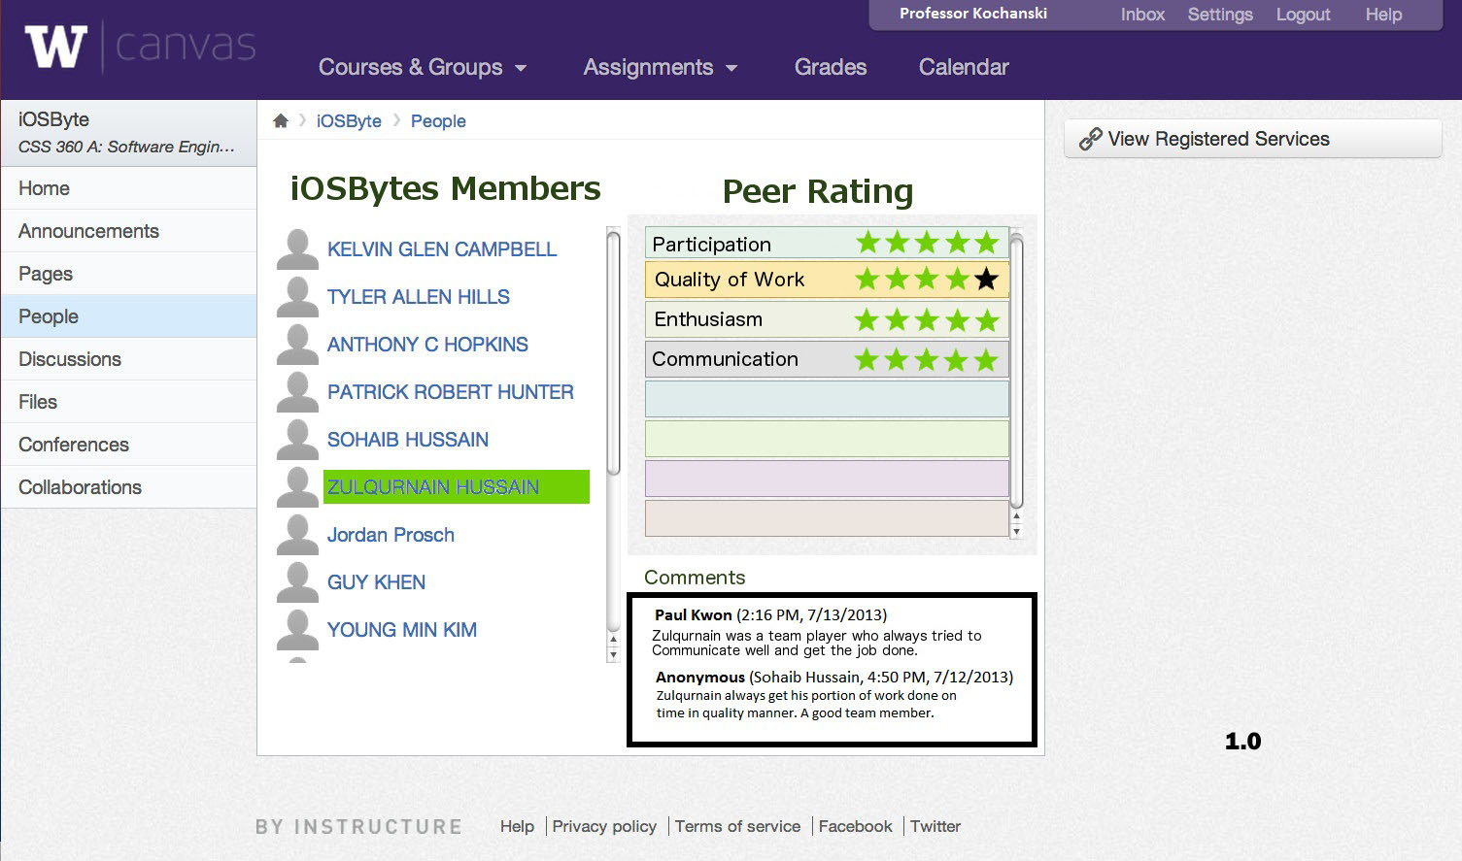

**Student view of other team members (version 1.0)**

The main difference between this and the previous picture is that you can only view your own comments, rather than everyone’s. Again, by clicking on a name, the website fetches information retrieved via the database (courtesy the database team).

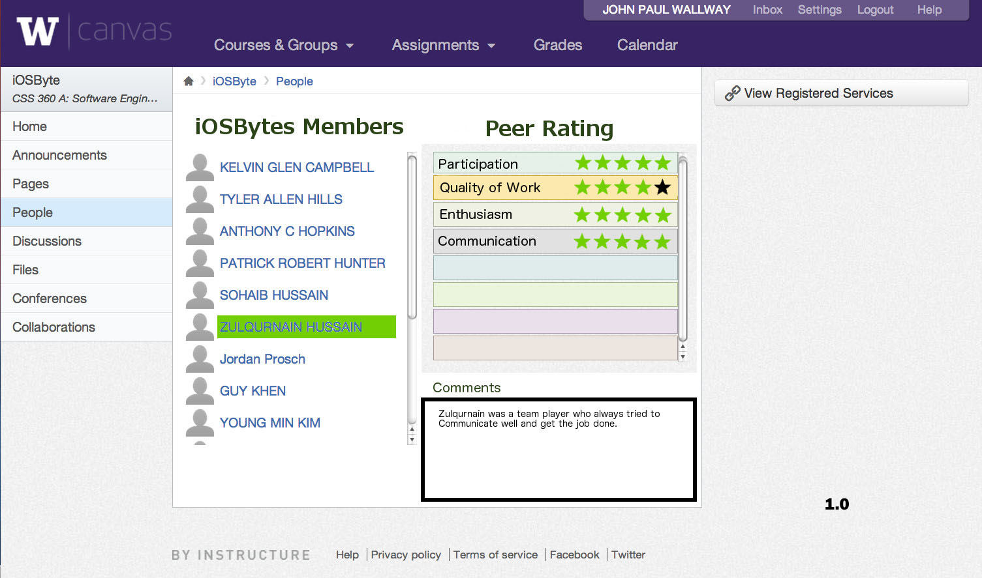

**Login page** (**version 1.0)**

It would use Canvas’ login, if that is what most instructors prefer. From here, you can login to your generic instructor/student homepage.

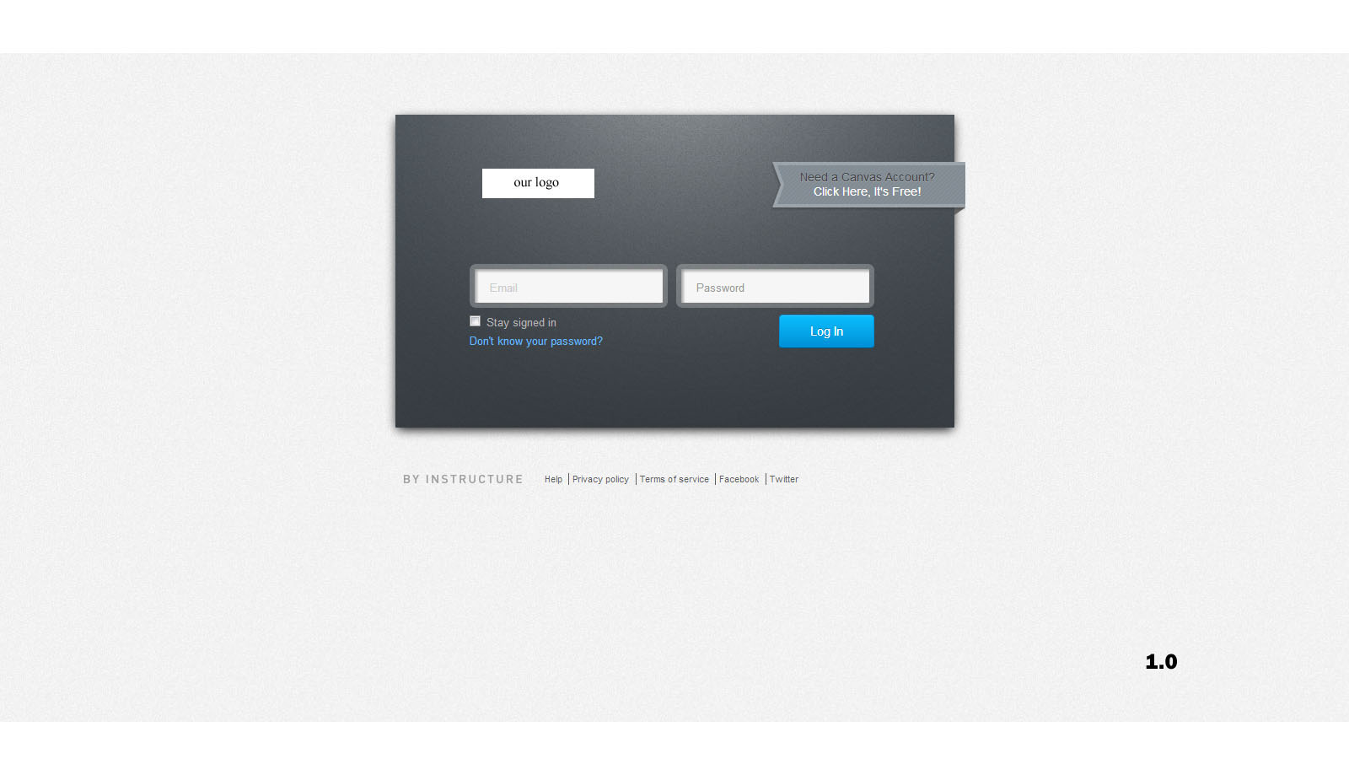

**Generic instructor homepage for a specific class (version 1.0)**

From here, the instructor can click on and view any team, and any of its members, including all of their reviews and ratings, complete with who wrote them.

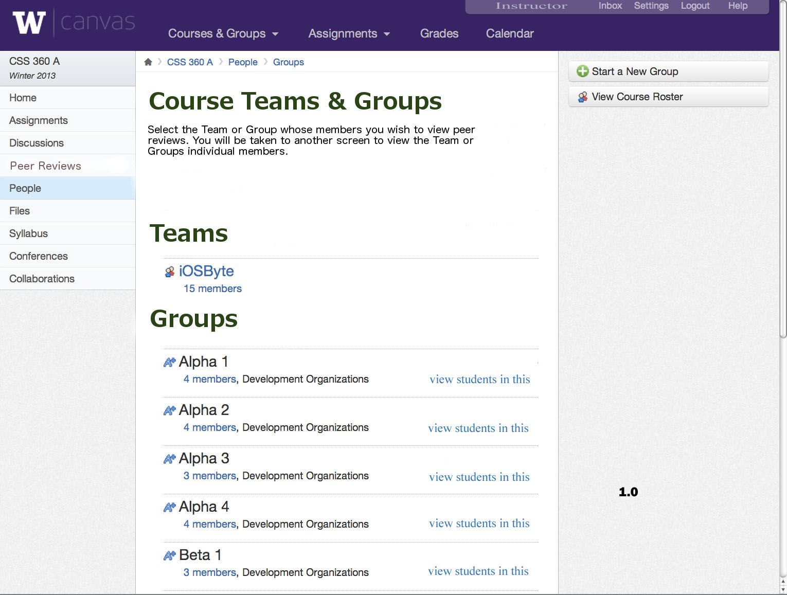

**Generic student page, version 1.0**

From here, you can navigate your course via the sidebar on the left, or the options in the middle.

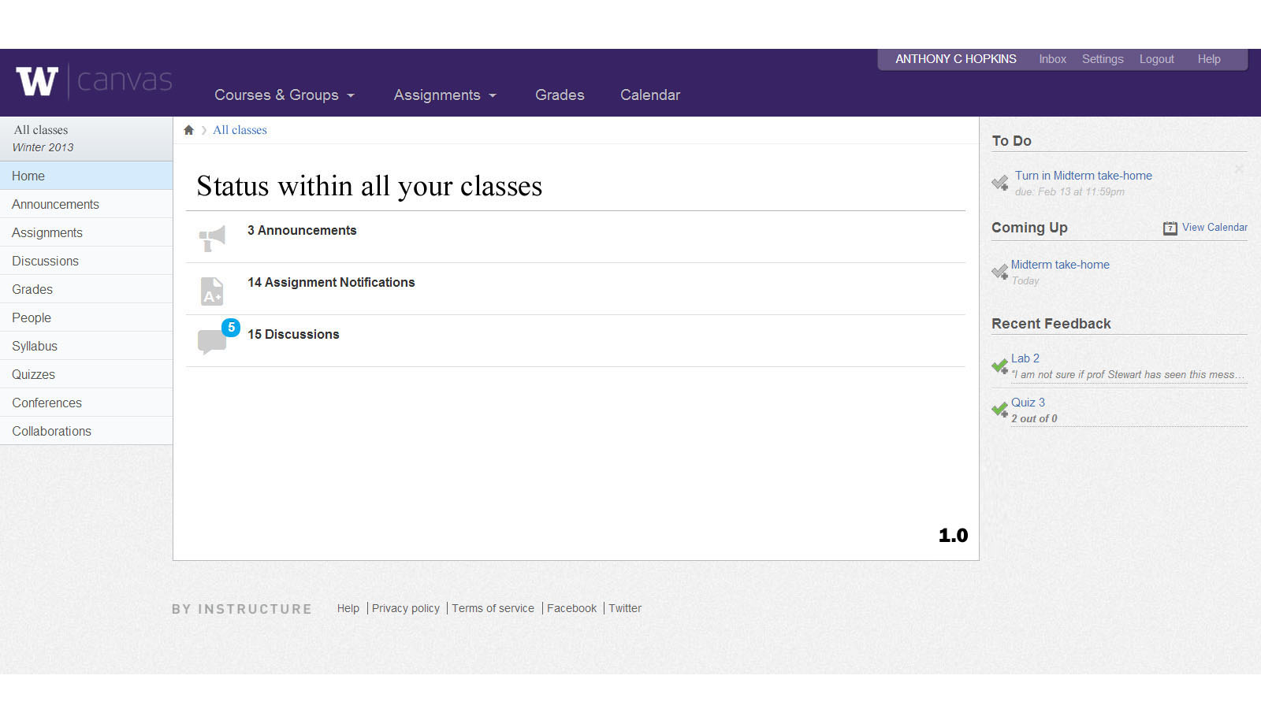**Generic instructor homepage (version 1.0)**

From here, an instructor can immediately navigate to students, or they can navigate to any specific course from here.

# **Generic instructor peer review creation page (version 1.0)**

From here, the instructor can create his own custom grading criteria (the list box in the middle of the page with participation, quality of work, etc). He can still view the students in the group/class/company from here (the list of hotlinked names on the left side), and navigate to other parts of his site (the nav bar on the left).

# C:\Users\Ifsozuan\Desktop\Version 1 design templates 360\Choosing grading criteria.jpg

**Artifacts: the next generation**

**Professor page for a team (version 2.0)**

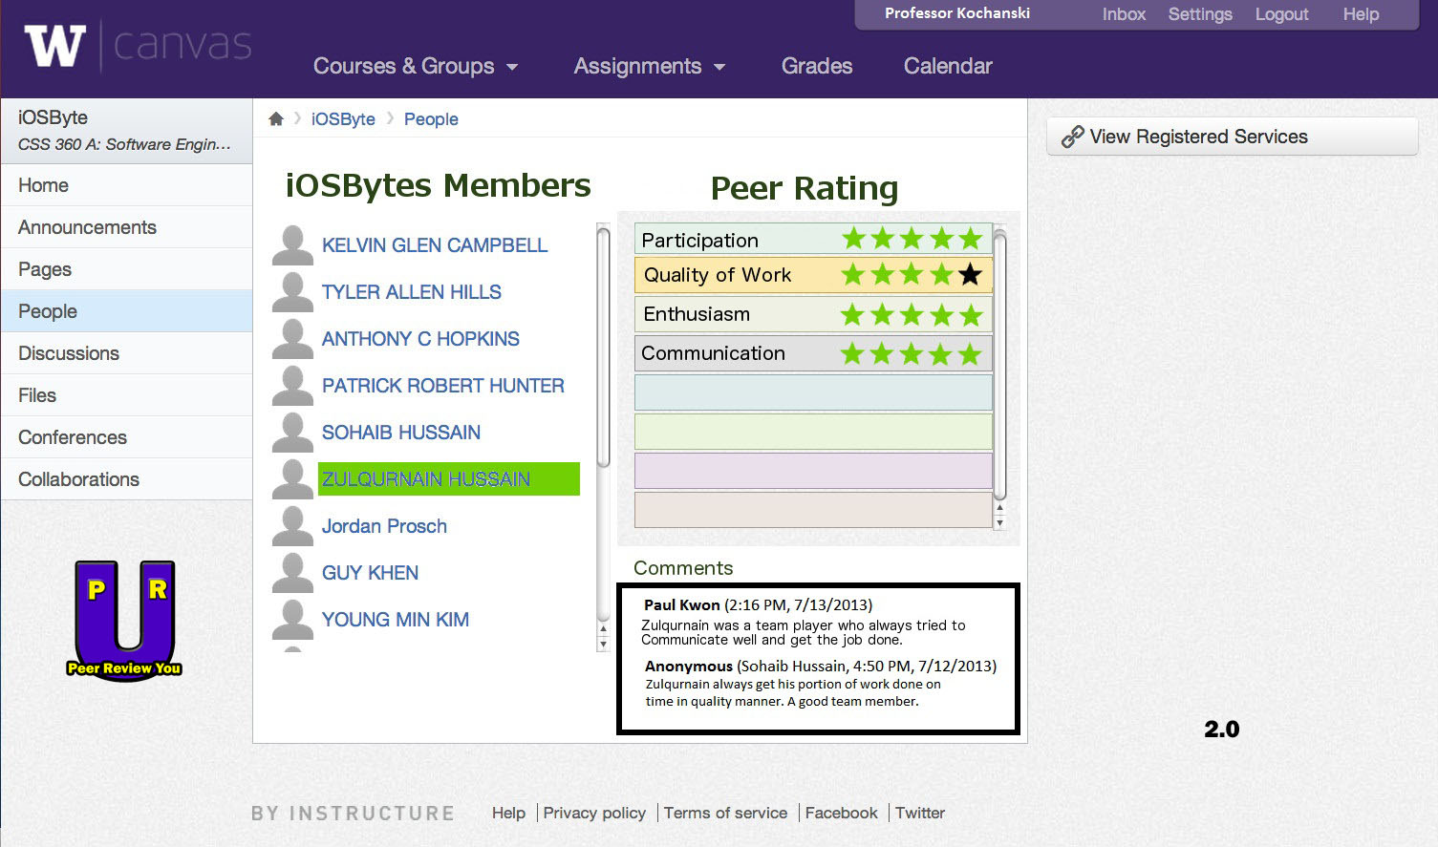* Difference between 1.0 and 2.0: added company logo to bottom left.

**Student team page (version 1.5)**

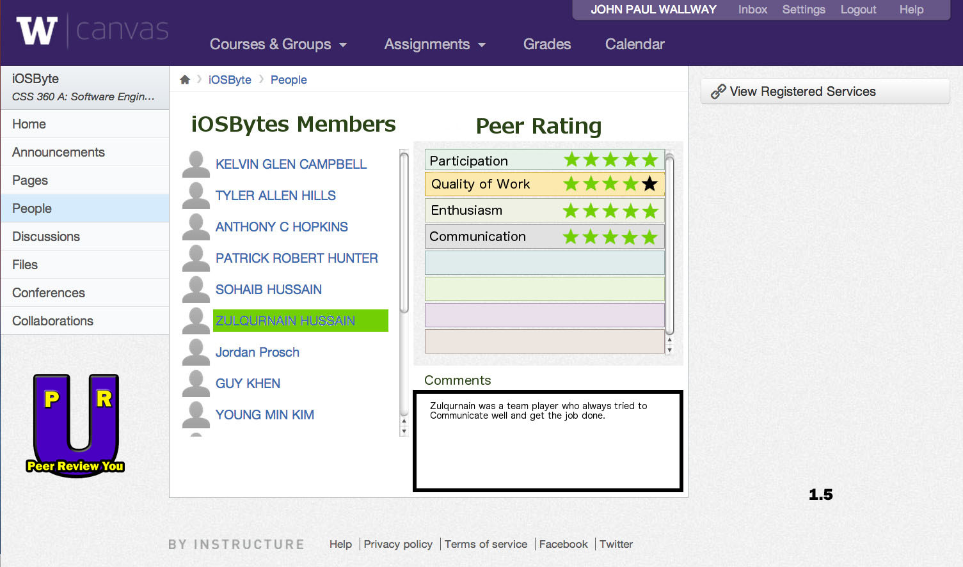* Differences between 1.0 and 1.5: added company logo to bottom left.

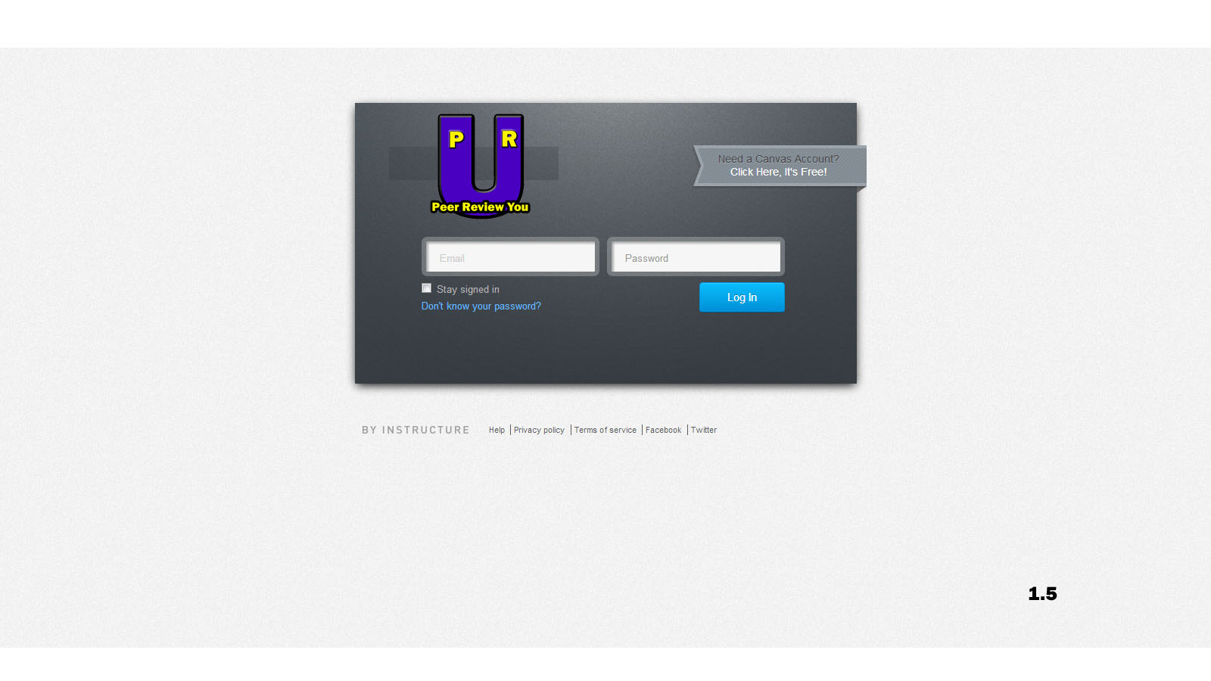**Generic login page (version 1.5)**

* Differences between 1.0 and 1.5: added company logo to top left.

**Generic instructor page (version 1.5)**

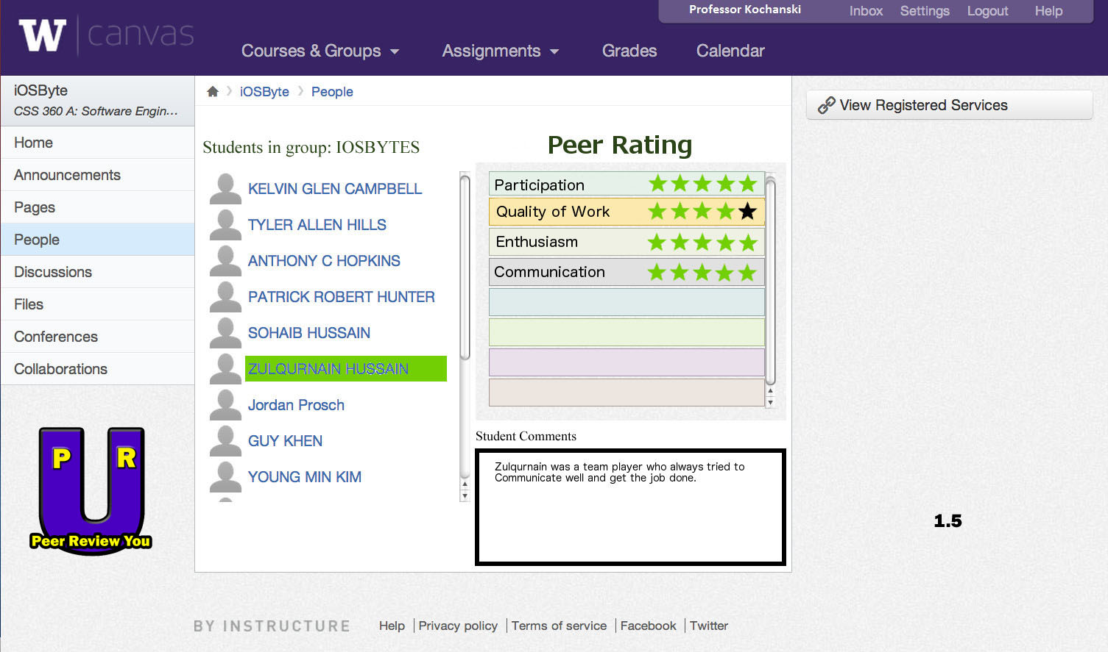

* Differences between 1.0 and 1.5: added company logo to bottom left.

**Generic instructor course page for peer reviewing (version 1.5)**

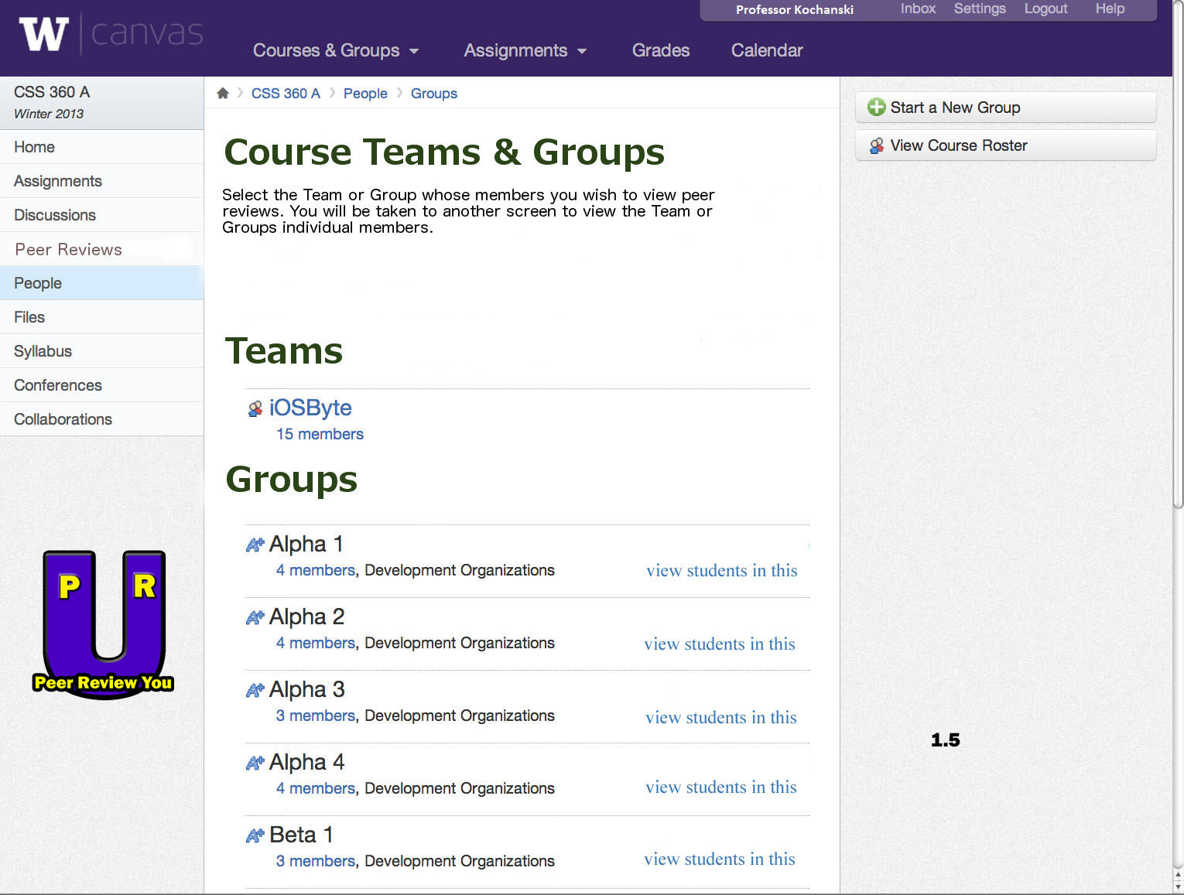

* Differences between 1.0 and 1.5: added logo to bottom left.

**Generic instructor homepage (version 1.5)**

* Differences between 1.0 and 1.5: added logo to bottom left.

**Generic student homepage (version 1.5)**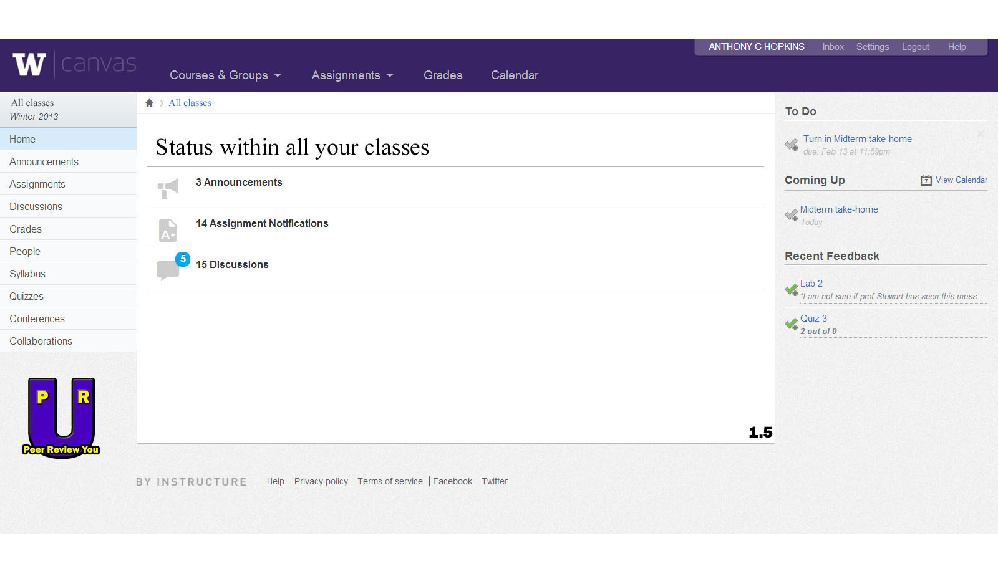

* Differences between 1.0 and 1.5: added logo to bottom left.

**Generic student homepage (version 1.5)**



* Differences between 1.0 and 1.5: added company logo.

**Generic instructor page (version 3.0)**

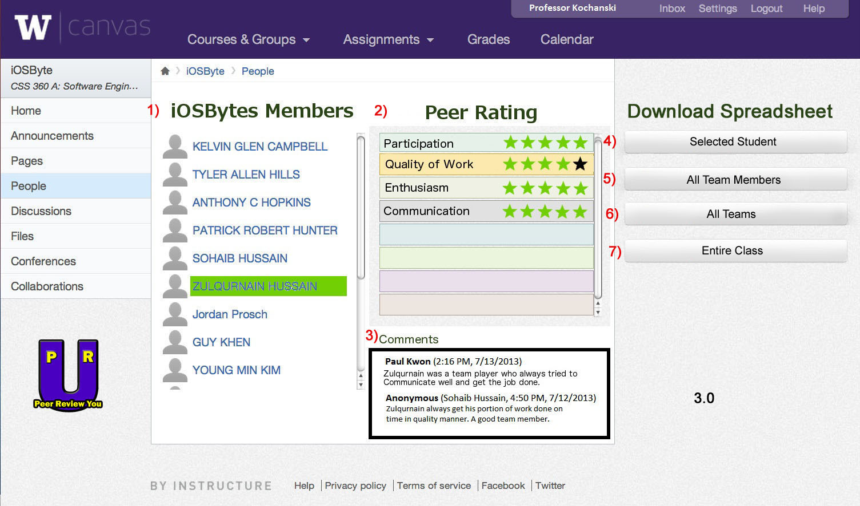

1) List of group members

2) Peer rating panel

3) Comment panel

4) Download spreadsheet version of selected student’s rating

5) Download spreadsheet version of all team members’ rating

6) Download spreadsheet version of all teams’ rating

7) Download spreadsheet version of entire class’s rating

* Differences between 2.0 and 3.0: added descriptions for numbered items; added a feature that allows instructor to download spreadsheet versions of ratings.

**Generic login page (version 1.5)**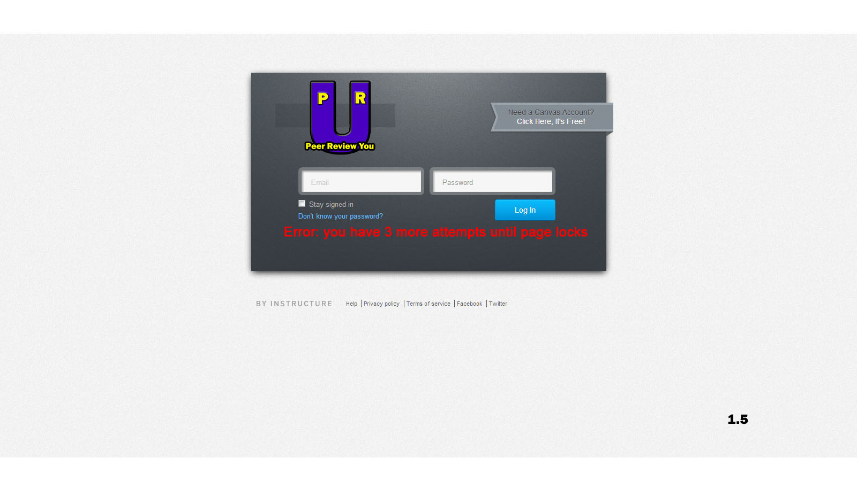

* Differences between 1.0 and 1.5:added a warning message that pops when user types in incorrect password for 5 instances.

**Courses Teams & Groups (version 2.0)**

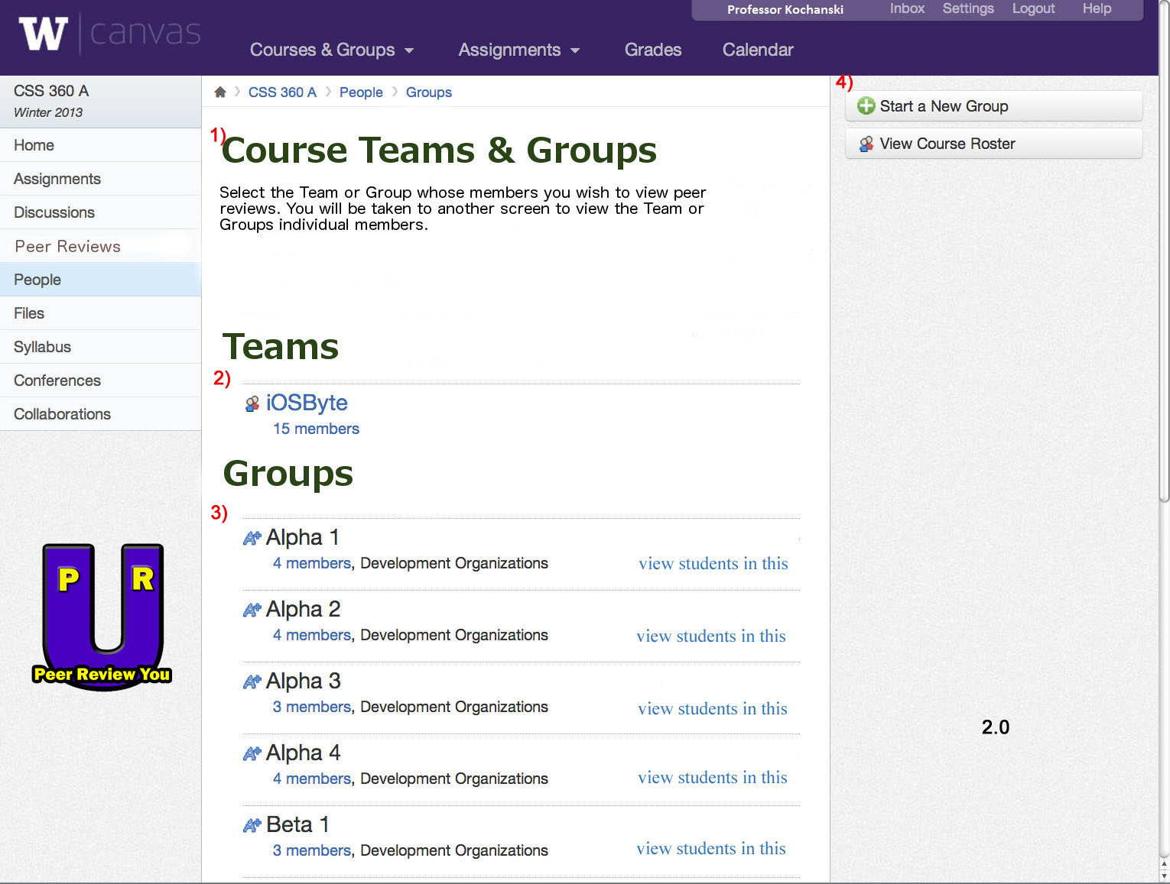

1) List of menus

2) List of teams

3) List of groups of selected team

4) Creates a new group into existing team

* Generic instructor course page for peer reviewing (version 1.5). Differences between 1.0 and 1.5: added descriptions for the numbered items.

**Generic instructor homepage (version 2.0)**



1) ~ 3) List of courses taught organized in chronological order (oldest being at the top)

* Differences between 1.5 and 2.0: added descriptions for numbered items.

**Generic student homepage (version 2.0)**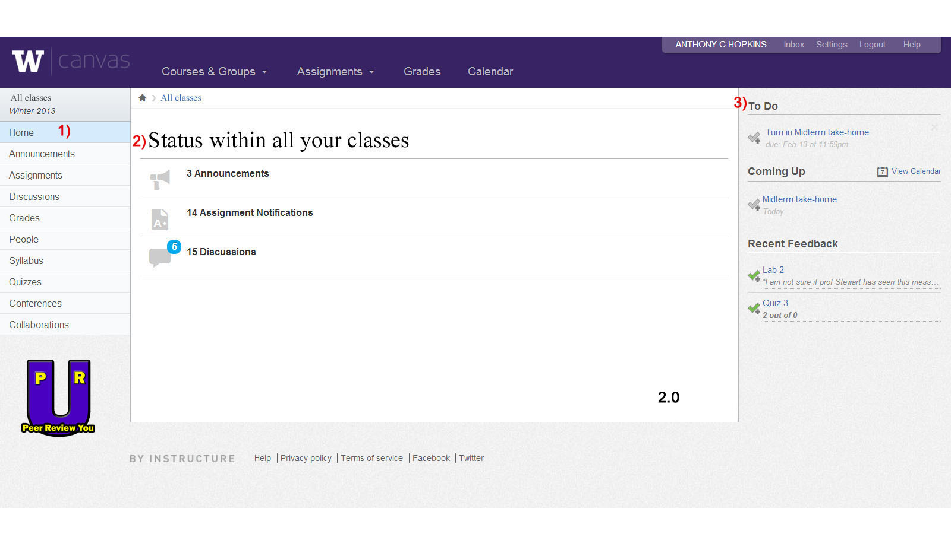

1) List of menus

2) List new updated statues from all of your classes

3) List of assignments that are due soon

* Differences between 1.5 and 2.0: added descriptions for numbered items.

**Databases To Use (courtesy Database team):**

BetaByte is in correspondence with the database team regarding some of the database schema and naming conventions. One correspondence is in the GIT Moving section of this document.

# Database Tables

Prepared by Guy Khen and Travis Olson

## Table 1 – names

|  |  |  |
| --- | --- | --- |
| Student/Instructor ID | Last Name | First Name |
| 1122313 | Fry | Phillip |
| 0342341 | Farnsworth | Hubert |
| 5346321 | Monkey | Gunter |

Instructor ID numbers start with ‘0’

## Table 2 – login information

|  |  |  |
| --- | --- | --- |
| ID Number | Username | Password |
| 1122313 | FryPJ | Il0vel33la |
| 0342341 | FarnHJ | wernstromsucks |
| 5346321 | MonkG | bananas |

## Table 3 – courses

|  |  |  |
| --- | --- | --- |
| Course ID | Course Name | Instructor ID |
| MUAAD | The Mathematics of Quantum Neutrino Fields | 0342341 |
| MUABD | English 101 | 0342341 |

## Table 4 – enrollment

|  |  |
| --- | --- |
| Student ID | Course ID |
| 1122313 | MUAAD |
| 1122313 | MUABD |
| 5346321 | MUAAD |

## Table 5 – comments

|  |  |  |
| --- | --- | --- |
| Comment ID | Content | Content |
| 6365324 | “Jerk” | 0 |

“Content” includes whatever we decide goes in there – comment, rating out of 10, whatever

## Table 6 – comment information

|  |  |  |  |  |
| --- | --- | --- | --- | --- |
| Comment ID | Giver ID | Receiver ID | Course ID | Date |
| 6365324 | 1122313 | 5346321 | MUADD | 21/5/3001 |

**USE CASES**

**Use Case ID: f001**

Instructor creates Peer Review Form

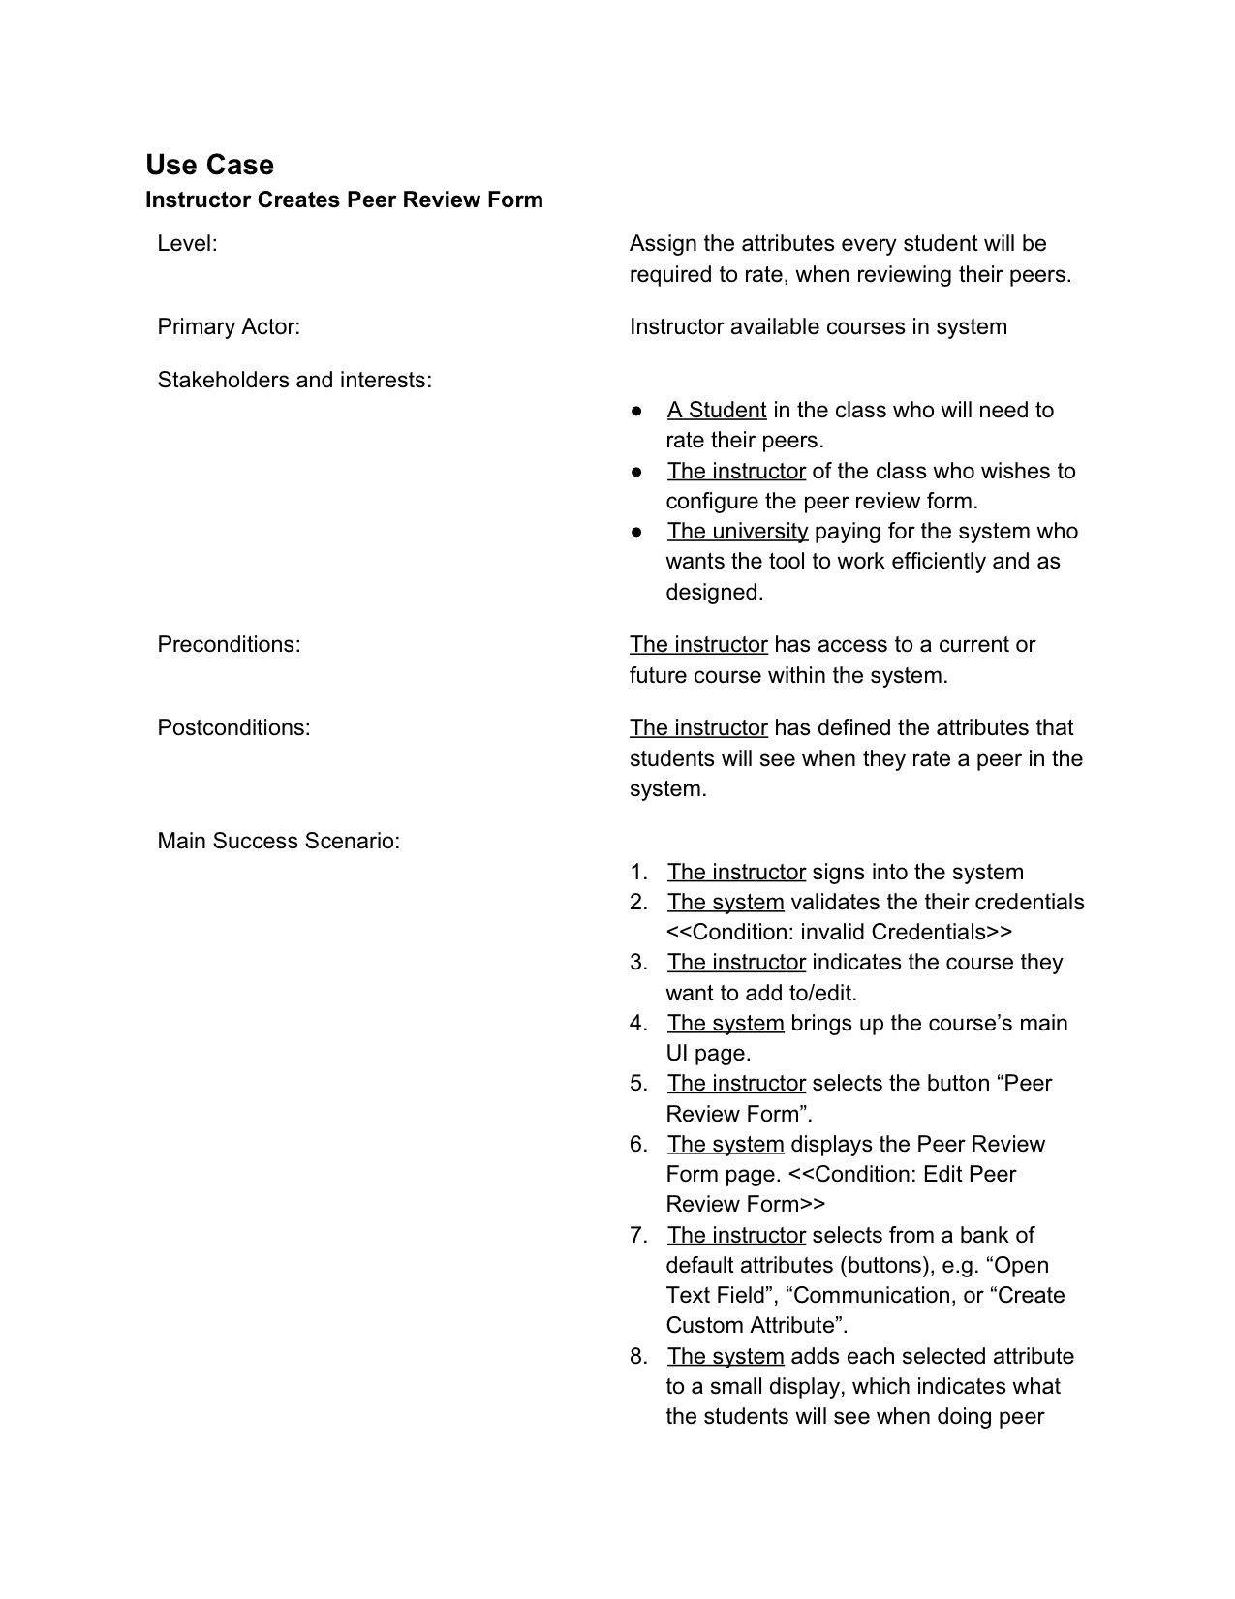

**Use Case ID: f002**

Student uses website to rate peers

* **Level:** Assigns values to other students based off the rating system and rating options available
* **Primary Actor:** Student utilizing the rating system
* **Stakeholders and Interests**:
  + A student utilizing the system
  + An instructor wishing to see his/her student’s ratings
  + The university wishing to use the system via payment
* **Preconditions:** A student has access to the website
* **Postconditions:** A student knows who they wants to rate, and how they wants to rate them
* **Main Success Scenario:**
  1. The student signs in to the system
  2. The system validates credentials of student
  3. The student navigates to the peer review system page (in LMS or separate site)
  4. The system updates the page the student has gone to by communication to the database
  5. The student selects a team member to peer review
  6. The student rates the peer with the given criteria(s)
  7. The system relays that information to the database, updating the current info on the students

**Use Case Diagram**

The following diagram describes the primary actions that can be taken by the users of this system. More actions may be defined and discovered as the project progresses. It should be noted that the administrator (Admin) role is not well defined and perhaps unnecessary. The role is provided here for future reference.

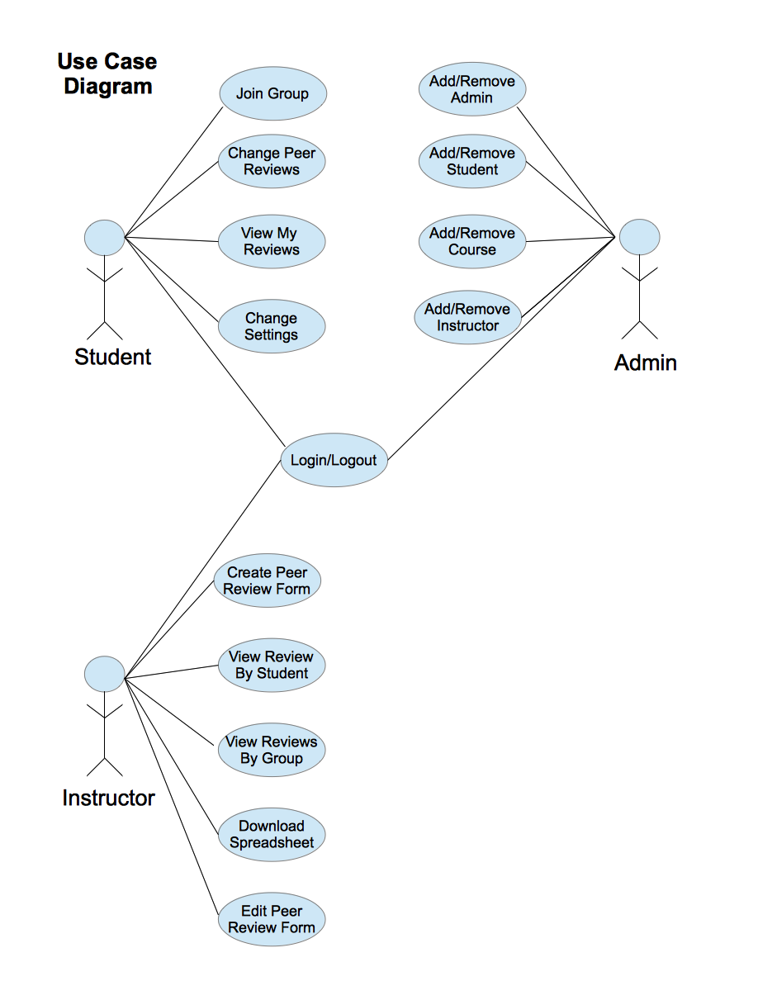

**GIT Moving**

Moving forward in this project all images, source code, and correspondences will be tracked and backed-up using GIT source control. This will allow the project to move forward quickly, avoid loss of work, avoid redundant work, allow team members to work concurrently, and allow the team to track efficiency. Included below are all files that are currently being tracked, the code in all non-binary files, and a log of all GIT commits up to date.

**Files currently in GIT repository:**

~/360website $ ls *

README.md

analysis:

use_case_create_review_form_v1.png use_case_diagram.png

correspondence:

db-team.txt

html:

README.md function locations.odt singles.txt

bottom.html nerdluv.css top.html

mockups:

choose_individual_v1.jpg group_list_v1.jpg instructor_class_list_v1.jpg

src:

confirm.php index.php login.php results.php

db_snippets.php index.phps matches.php signup.php

**Non-Binary Repository Source Files:**

diff --git a/correspondence/db-team.txt b/correspondence/db-team.txt

index 0000000..c86f90c

Database Correspondence:

* Database names, table names, and column names should not contain spaces. People use camelCasing or under_bars generally to separate words.

* What is the database name?

* The courses table should have a 'Schedule Line Number' or 'Section' column, for when there is more than one time slot offering for a particular course

* The enrollment table should have 'year' and 'quarter' columns

* The 'question information' table seems like it should be 'peer_ratings' and it should include a 'rating' column and a 'comment' column (the '/answer' part of the 'questions' table can be removed.

* The questions table should only hold information about questions and should contain a 'rating_scale' column

* There should be a table for keeping track of teams' and groups' members and the team/group names. e.g.

| team_or_group_name | user_id |

| iOSByte | 123456 |

| Overbyte | 123456 |

* The ratings questions table can be combined with the question information table (the uniqueness of rows in the 'question information'--or peer_ratings--table can be determined by the question_id, giver_id, and receiver_id)

Thanks,

John Paul

diff--gita/analysis/use_case_create_review_form_v1.png b/analysis/use_case_create_review_form_v1.png

index 0000000..7bb0e8b

diff --git a/analysis/use_case_diagram.png b/analysis/use_case_diagram.png

new file mode 100644

index 0000000..2043aad

diff --git a/html/bottom.html b/html/bottom.html

index 0000000..f65d5fc

<!--

shared page bottom HTML

-->

<div>

<p>

This is a Peer Review U maintained service page; please submit questions and comments to inquiries@peerreviewu.com.

</p>

<p>

Results and page (C) Copyright Peer Review U

</p>

<ul>

<li>

<a href="index.php">

<img src="http://www.peerreviewu.com/home_link" />

Back to home page

</a>

</li>

</ul>

</div>

<div id="logo">

<img src="http://www.peerreviewu.com/logo" />

</a>

</div>

</body>

</html>

diff --git a/mockups/choose_individual_v1.jpg b/mockups/choose_individual_v1.jpg

index 0000000..8524ecc

diff --git a/mockups/group_list_v1.jpg b/mockups/group_list_v1.jpg

index 0000000..5bf345b

diff --git a/mockups/instructor_class_list_v1.jpg b/mockups/instructor_class_list_v1.jpg

index 0000000..278ee4c

diff --git a/src/confirm.php b/src/confirm.php

index 0000000..6687c44

<!--

Peer Review U

BetaByte webDev Team: Anthony C. Hopkins, Sohaib Hussain, Paul Park Kwon, John Paul Wallway

CSS 360

-->

<?php

include("top.html");

$name = $_POST["name"];

$gender = $_POST["gender"];

$age = $_POST["age"];

$type = $_POST["personality"];

$os = $_POST["os"];

$min = $_POST["min"];

$max = $_POST["max"];

$line = "$name,$gender,$age,$type,$os,$min,$max\n";

file_put_contents("singles.txt", $line, FILE_APPEND);

?>

<p>Thank you!</p>

<p>Welcome to Peer Review U, <?= $name ?>!</p>

<p>Now <a href="login.php">log in to review!</a></p>

<?php include("bottom.html"); ?>

diff --git a/src/db_snippets.php b/src/db_snippets.php

index 0000000..2cf11e8

<-----

Peer Review U

BetaByte webDev Team: Anthony C. Hopkins, Sohaib Hussain, Paul Park Kwon, John Paul Wallway

CSS 360

------>

// Database snippets for general use

<?php

// Create connection

$con=mysqli_connect("peerreviewu.com","app_user","escrowed_pass","uwb_db");

// Check connection

if (mysqli_connect_errno($con))

{

echo "Failed to connect to MySQL: " . mysqli_connect_error();

}

// Get student's courses

$student_courses = mysqli_query($con,"SELECT course_id FROM enrollment where student_id = 12345");

// Get instructor's courses

$instructor_courses = mysqli_query($con,"SELECT course_id FROM courseswhere instructor_id = 67890");

// get id_number

$user_pass = getPassword()

$id_number = mysqli_query($con,"SELECT id_number from login_information where password = '$user_pass'");

?>

diff --git a/src/index.php b/src/index.php

index 0000000..4262bef

--- /dev/null

++ b/src/index.php

@@ -0,0 +1,28 @@

<?php include("top.html"); ?>

<!--

Peer Review U

BetaByte webDev Team: Anthony C. Hopkins, Sohaib Hussain, Paul Park Kwon, John Paul Wallway

CSS 360

-->

<div>

<h1>Welcome!</h1>

<ul>

<li>

<a href="signup.php">

<img src="http://www.peerreviewu.com/

Sign up for a new account

</a>

</li>

<li>

<a href="login.php">

<img src="http://www.peerreviewu.com/login.gif" alt="icon" />

Login now

</a>

</li>

</ul>

</div>

<?php include("bottom.html"); ?>

diff --git a/src/index.phps b/src/index.phps

index 0000000..420a424

--- /dev/null

++ b/src/index.phps

@@ -0,0 +1,28 @@

<?php include("top.html"); ?>

<!--

Peer Review U

BetaByte webDev Team: Anthony C. Hopkins, Sohaib Hussain, Paul Park Kwon, John Paul Wallway

CSE 360

-->

<div>

<h1>Welcome!</h1>

<ul>

<li>

<a href="signup.php">

<img src="<img src="http://www.peerreviewu.com/signup.gif" alt="icon" />

Sign up for a new account

</a>

</li>

<li>

<a href="confirm.php">

<img src="<img src="http://www.peerreviewu.com/login.gif" alt="icon" />

Login

</a>

</li>

</ul>

</div>

<?php include("bottom.html"); ?>

diff --git a/src/login.php b/src/login.php

index 0000000..5c2f307

<!--

Peer Review U

BetaByte webDev Team: Anthony C. Hopkins, Sohaib Hussain, Paul Park Kwon, John Paul Wallway

CSE 360

login.php just contains a field for returning users login info

-->

<?php include("top.html"); ?>

<form action="results.php" method="get">

<fieldset>

<legend>Returning User:</legend>

<ul>

<li><strong>Name: </strong><input type="text" size="16" name="retname" /></li

</ul>

<input type="submit" value="View My Reviews" />

</fieldset>

</form>

<?php include("bottom.html"); ?>

**Git log:**

commit 9b4a05813d5ee9fab078fdcac4dca3616bcc714d

Author: jeanpi <johnpaulwallway@gmail.com>

Date: Tue Mar 12 22:35:18 2013 -0700

moving source files from html dir to src dir

commit de9b4b31d230488c8963d33660ce1366065abed9

Author: PAUL PARK KWON <ppk0907@uw1-320-template>

Date: Tue Mar 12 15:08:54 2013 -0700

HTML PHP Samples

commit 19068c59b979fe90a9bd381f7b96aee4b4714347

Author: jeanpi <johnpaulwallway@gmail.com>

Date: Mon Mar 11 21:31:26 2013 -0700

Correcting index aznd bottom.html

commit 0b3bce86b157a7f8c3495ef04b27be0f088de4cb

Author: jeanpi <johnpaulwallway@gmail.com>

Date: Mon Mar 11 20:59:40 2013 -0700

adding a couple more mysql querries

commit 62c12bc7841b5415c16bcbeab2092e2dea1fef0c

Author: jeanpi <johnpaulwallway@gmail.com>

Date: Sat Mar 9 16:19:57 2013 -0800

Forgot to actually add the correspondence dir

commit d0a90c0795269c3a20f9bcdc71d32449d37fc669

Author: jeanpi <johnpaulwallway@gmail.com>

Date: Sat Mar 9 16:16:24 2013 -0800

Adding db correspondence

commit 91ba1f0aa0a15aea906958aebdbedfd4741eb59e

Author: jeanpi <johnpaulwallway@gmail.com>

Date: Sat Mar 9 14:10:11 2013 -0800

Adding login page

commit 30f2f7242db0119a896124d82e88e14ebf79a2c2

Author: jeanpi <johnpaulwallway@gmail.com>

Date: Sat Mar 9 14:09:39 2013 -0800

Updating PHP titles/files

commit 41bd5d42b43a7a7f8e378dce3253c0583fb8c918

Author: jeanpi <johnpaulwallway@gmail.com>

Date: Sat Mar 9 13:56:44 2013 -0800

updating html bottom of page template

commit 4d0923c85f887dc74f60700f29e03ba729b5aeae

Author: jeanpi <johnpaulwallway@gmail.com>

Date: Sat Mar 9 12:22:13 2013 -0800

Removing obsolete files from main directory

commit a98377e5d31769e6813594b9ff93359533ce4d4e

Author: jeanpi <johnpaulwallway@gmail.com>

Date: Sat Mar 9 12:19:10 2013 -0800

Creating directory structure and organizing files

commit bf4932a9e6b948dbbeebb62f7013682c52924086

Author: jeanpi <johnpaulwallway@gmail.com>

Date: Sat Mar 9 12:10:04 2013 -0800

Adding instructor create review form use case

commit 329330330f60931b1a713870e328c48ebb6474a4

Author: jeanpi <johnpaulwallway@gmail.com>

Date: Sat Mar 9 12:07:07 2013 -0800

Adding v1 mockups for instructor class view, class groups view, and view individual scores

commit ec8350504d96df4bd81ccaacad7013ce4fd6fd1e

Author: jeanpi <johnpaulwallway@gmail.com>

Date: Sat Mar 9 11:55:04 2013 -0800

Site use case diagram

commit 33d8150f73fbcefe704fe46c735716b0d9d616e1

Author: SOHAIB HUSSAIN <sohaibh2@uw1-320-17.uwb.edu>

Date: Thu Mar 7 17:26:13 2013 -0800

adding example files for site functionality

commit a124b8bc1a06e46d4c27248a137765f896ea3a89

Author: jeanpi <johnpaulwallway@gmail.com>

Date: Thu Feb 28 16:42:25 2013 -0800

first snippet

commit 3ba3906d81aa3e7ccce7556d3e9796ac25ed08d9

Author: SOHAIB HUSSAIN <sohaibh2@uw1-320-18.uwb.edu>

Date: Thu Feb 28 16:15:13 2013 -0800

just figuring out how to commit/push

commit a55d1b8c3c74f33cd0edfa1ea9bc4a74faf3ed0b

Author: SOHAIB HUSSAIN <sohaibh2@uw1-320-18.uwb.edu>

Date: Thu Feb 28 16:12:49 2013 -0800

just figuring out how to commit/push

commit 24cc588460d8254feea5e6ee48dea00d035dade3

Author: jeanpi <johnpaulwallway@gmail.com>

Date: Thu Feb 14 17:25:47 2013 -0800

Initial commit